PURPOSE (APPLICATION)
  - To describe the process to create dilute bleach solutions (~0.12% sodium hypochlorite) for use of disinfection of surfaces.

RESPONSIBILITIES
  - This procedure should be followed by anyone diluting solutions of bleach to use for disinfecting surfaces
    - Bleach is not the only disinfectant that can be used, however, it is cheap, effective, and readily available. Should one choose to use dilute bleach solutions for disinfection, the following must be observed.
SAFETY PRECAUTIONS
  - Always wear appropriate personnel protective equipment (PPE) such as gloves, lab coat, and protective eye wear.
  - Read the safety data sheet (SDS) and the corrosives SOP prior to using. The SDS for Clorox household bleach is here.
  - Bleach will remove color from fabrics and is corrosive (H314) to metal. It is a strong oxidizer, so chemical compatibility must be assessed when using bleach. For example, bleach can react with dishwashing soap that contains ammonia to form chloramine gas, which is toxic. Bleach will also react with acids (including vinegar) to release chlorine gas, which is highly toxic. Bleach itself is toxic, an irritant, and corrosive.
  - Know the concentration of sodium hypochlorite in the bleach solution. This can be found on the label and is important in order to calculate the appropriate dilute concentration.
MATERIALS

Household bleach herein referred to as “bleach” has traditionally been formulated at 5.25%. sodium hypochlorite which equals 52,500 ppm sodium hypochlorite. Bottles of bleach should be marked with the date of receipt and again with the date of opening. Note the date the bottle of bleach was opened. Concentrated bleach should be used within 1 year of opening.

Note: 5.25% sodium hypochlorite may no longer be commercially available. Current concentrations may be 6 or 8.25%.
  - Containers for making dilute bleach.
  - Measuring tools (e.g., graduated cylinders).
PROGRAM OVERVIEW
  - Follow all safety precautions and wear appropriate PPE.
  - Calculate the appropriate amount of bleach to be added to the sample that will provide a final concentration of 0.12% sodium hypochlorite. This will vary depending on the original concentration of sodium hypochlorite in the liquid bleach. Michigan State has released guidance on how to appropriately dilute bleach solutions based off of original sodium hypochlorite solutions. The infographic is below.

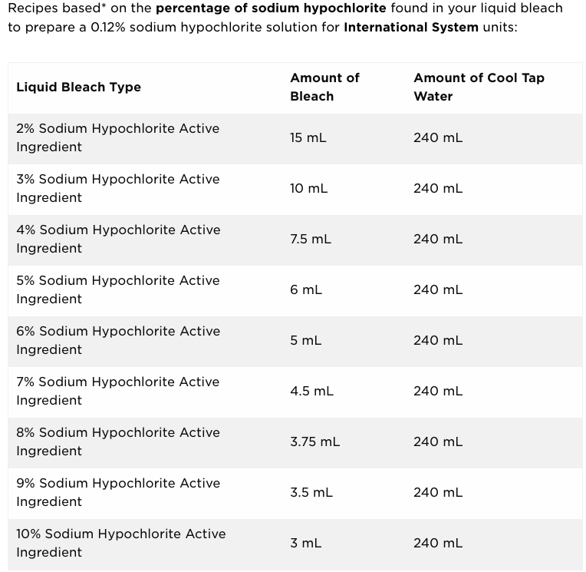

  - Affix a label to the container: “0.12% Sodium Hypochlorite”, with the date, your name, and the time.
  - A contact time of 1-10 minutes is required for effectiveness
  - Following disinfection, the surface should be wiped with clean water to remove residue.

REFERENCES
  - Anderson, E., and J. Li. March 13, 2020. COVID-19 – Disinfecting with Bleach. Michigan State University, Center for Research on Ingredient Safety. Available at: https://www.canr.msu.edu/news/covid-19-disinfecting-with-bleach
  - Center for Disease Control. 2019. Cleaning and Disinfection for Households: Interim Recommendations for U.S. Households with Cornavirus Disease 2019. Available at: https://www.cdc.gov/coronavirus/2019-ncov/prevent-getting-sick/cleaning-disinfection.html

TRAINING REQUIREMENTS
  - New lab personnel will be trained by observing experienced lab personnel performing the procedure.
  - This SOP is required training for all personnel who disinfect surfaces using dilute bleach solutions.
REVISION HISTORY
Version | Effective Date | Summary of Change
1 | 5-14-2020 | Develop new SOP
2

